Table S1. Morphological measurements (in mm) of all castes of *Acanthomyrmex concavus*. Measurement acronyms are presented in the main text. EQ: ergatoid queen.

|  |  |  |  |
| --- | --- | --- | --- |
| Measuring section | EQ (n = 4) 　　　　　(Mean ± SD） | Major (n = 6)　　　　　(Mean ± SD） | Minor (n = 20) 　　　　　　　(Mean ± SD） |
| HL | 1.30 ± 0.06 | 2.39 ± 0.97 | 1.08 ± 0.05 |
| HW | 1.38 ± 0.06 | 2.19 ± 0.06 | 1.12 ± 0.04 |
| EL | 0.14 ± 0.01 | 0.15 ± 0.01 | 0.13 ± 0.06 |
| SL | 0.92 ± 0.02 | 0.99 ± 0.03 | 0.86 ± 0.04 |
| MW | 0.72 ± 0.03 | 0.79 ± 0.01 | 0.72 ± 0.03 |
| ML | 1.19 ± 0.03 | 1.26 ± 0.04 | 1.21 ± 0.03 |
| ATW | 1.12 ± 0.04 | 1.16 ± 0.04 | 0.83 ± 0.05 |
| ATL | 1.24 ± 0.05 | 1.25 ± 0.01 | 0.88 ± 0.05 |
| PnSL | 0.10 ± 0.01 | 0 | 0.21 ± 0.04 |
| PdSL | 0.44 ± 0.02 | 0.42 ± 0.03 | 0.46 ± 0.05 |
| PL | 0.55 ± 0.04 | 0.59 ± 0.06 | 0.48 ± 0.03 |
| PH | 0.35 ± 0.02 | 0.37 ± 0.01 | 0.29 ± 0.01 |
| PPL | 0.25 ± 0.03 | 0.30 ± 0.02 | 0.21 ± 0.02 |
| PPH | 0.36 ± 0.01 | 0.35 ± 0.01 | 0.26 ± 0.02 |

Table S2. Morphological indices for all castes of *Acanthomyrmex concavus*. Index acronyms are presented in the main text. EQ: ergatoid queen.

|  |  |  |  |
| --- | --- | --- | --- |
| Indices | EQ (n = 4) 　　　　　(Mean） | Major (n = 6 )　(Mean） | Minor (n = 20) 　　　　　　　(Mean） |
| CI | 106 | 92 | 104 |
| EI | 10.3 | 6.6 | 11.3 |
| SI | 67 | 45 | 77 |
| PnSI | 8.17 | 0 | 17.3 |
| PdSI | 36.6 | 33.4 | 38 |
| PI | 156 | 161 | 162 |
| PPI | 69 | 85 | 81 |

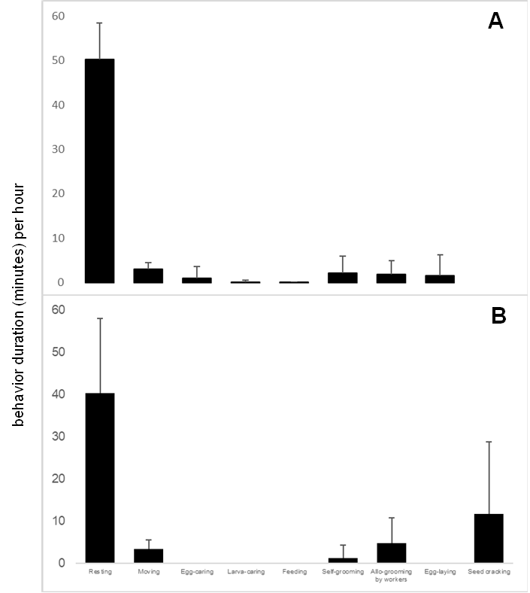

Fig. S1. Behavior of the queen in the HK23-01 colony(A) with all castes and brood and (B) without major workers and brood, which had died. (N = 10 for each colony state, mean time (minutes) ± SD).

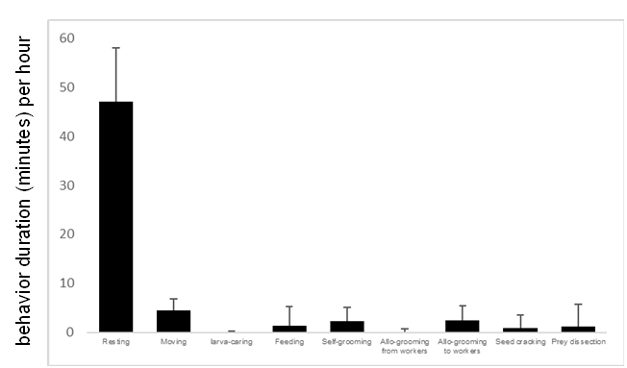

Fig. S2. Behavior of four major workers (three from colony HS23-104, one from colony HK23-01). Each individual was observed for five sessions of one hour. All colonies contained brood and all castes at the time of observation.