Electronic supplementary material

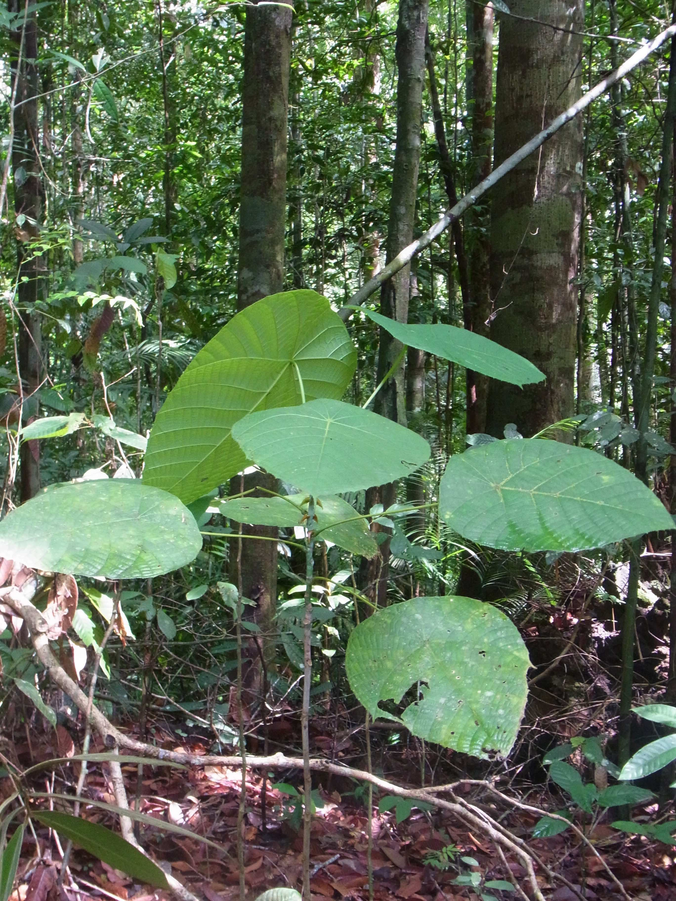
Figure S1. A sapling of Macaranga lamellata in the study site.

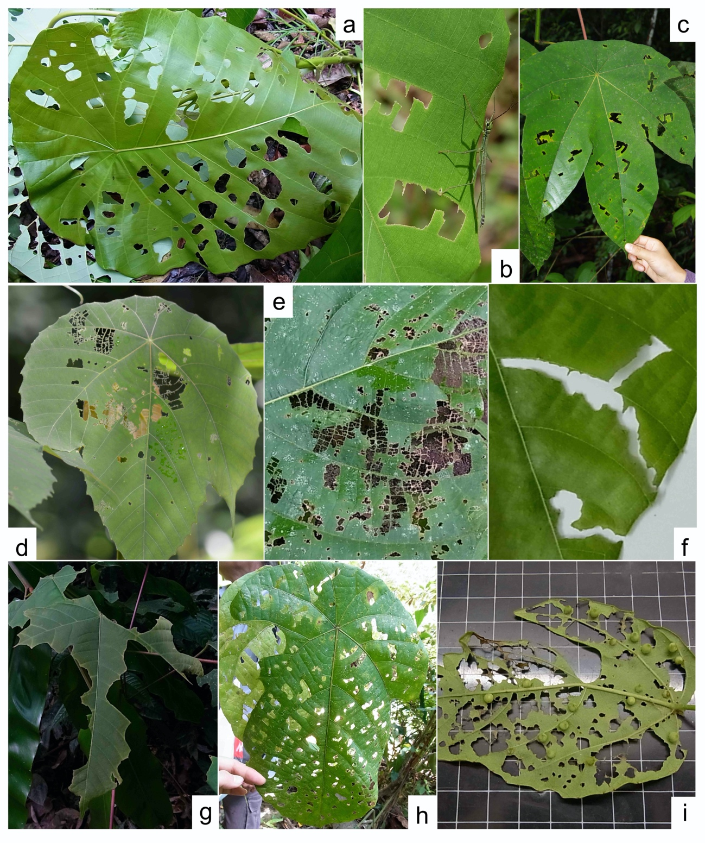
Figure S2. The typical feeding marks of four types of chewing herbivory on Macaranga leaves in the study site: (a) lepidopteran chewing marks on M. recurvata, (b) chewing-marks made by a nymph of Orthomeria alexis on M. bancana and the nymph, (c) chewing marks made by phasmids on a M. trachyphylla leaf; middle row: orthopteran chewing marks: (d) chewing marks made by a cricket species of Nisitrus on a M. bancana leaf, (e) chewing marks made by Nisitrus sp. on a M. winkleri leaf, (f) chewing marks made by a grasshopper species on a M. bancana leaf; lower row: chewing marks made by unknown leaf-chewing species: (g) a M. bancana leaf most area of which was lost probably due to herbivory, (h) chewing marks made by unknown leaf-chewers on an old leaf of M. lamellata, (i) chewing marks made by probably various leaf-chewing species on a M. beccariana leaf.

Table S1. Mean head widths (mm) of workers of Colobopsis macarangae and of three Crematogaster species which were reported to be associated with Macaranga lamellata in two previous studies.
Ant species Head width (± S.E.) Reference
/head width range
Co. macarangae 0.99 ± 0.08 Dumpert 1996 ¹
Cr. linsenmairi 0.63–0.86 Feldhaar et al. 2016 ²
Cr. borneensis 0.63–0.92 Feldhaar et al. 2016 ²
Cr. captiosa 0.51–0.70 Feldhaar et al. 2016 ²

¹⁾ Dumpert K, 1996. Appendix. Description of Camponotus macarangae, new species. In: Maschwitz U, Fiala B, Davies SJ and Linsenmair KE, A south-east Asian myrmecophyte with two alternative inhabitants: Camponotus or Crematogaster as partners of Macaranga lamellata. Ecotropica 2: 38-40.
²⁾ Feldhaar H, Maschwitz U and Fiala B, 2016. Taxonomic revision of the obligate plant-ants of the genus Crematogaster Lund (Hymenoptera: Formicidae: Myrmicinae), associated with Macaranga Thouars (Euphorbiaceae) on Borneo ant the Malay Peninsula. Sociobiology 63: 651-681.

