**Flight muscle histolysis in *Lasius niger* queens**

Arthur Matte 1* and Johan Billen 2

1. 5 Le Bouffay, 35470 Bain de Bretagne, France

2. KU Leuven, Zoological Institute, Naamsestraat 59, box 2466, B-3000 Leuven, Belgium

*author for correspondence: **matte.arthur01@gmail.com**

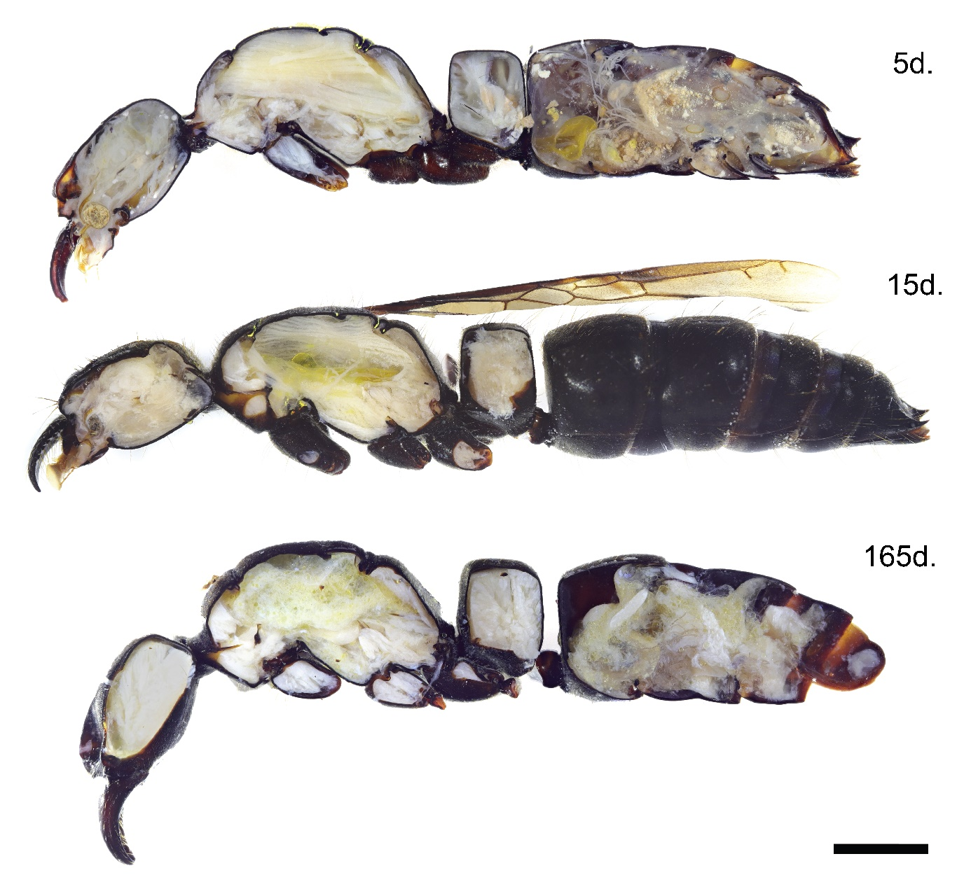

Fig. S1. Three stages of flight muscle histolysis in *Pachycondyla crassinoda* queens. The time indication for each queen shows the number of days between the queens’ collection and their fixation. Scale bar 2 mm.